Penetration Test Report

Mission Pumpkin v1.0 — PumpkinFestival
Field | Value
Prepared by | Kali Operator
Course / Module | Ethical Hacking — Elewayte
Target | Mission Pumpkin v1.0 (PumpkinFestival) — VulnHub
Attacker Machine | 192.168.1.8
Target Machine | 192.168.1.15
Assessment Date(s) | July 25, 2026
Report Date | July 25, 2026

1. Executive Summary
Briefly describe the objective of the assessment, scope, and overall outcome (e.g., root access achieved, number of tokens captured, PumpkinFestival_Ticket retrieved).
A black-box penetration test was performed against the Mission Pumpkin v1.0 (PumpkinFestival) VulnHub VM at 192.168.1.15. Initial access was obtained via an SSH private key recovered from an anonymously-accessible FTP share, granting a foothold as the user emily. A misconfigured passwordless sudo rule for /usr/bin/tar was identified as the privilege escalation vector, and root access was confirmed. All 10 PumpkinTokens were captured across the recon, scanning, exploitation, and privilege-escalation phases, and the final PumpkinFestival_Ticket flag was successfully retrieved.

Scope
Single VulnHub VM (192.168.1.15) on an isolated 192.168.1.0/24 lab network; attacker host at 192.168.1.8. No other systems in scope.

Overall Result
Metric | Result
Root Access Achieved | Yes
Tokens Captured | 10 / 10
Final Ticket Captured | Yes
Critical Findings | 1 (passwordless sudo tar privilege escalation)

2. Methodology
Describe the overall approach used, e.g., a standard penetration testing methodology: Reconnaissance -> Scanning & Enumeration -> Exploitation -> Privilege Escalation -> Post-Exploitation / Reporting.

2.1 Reconnaissance
Tools used: netdiscover, arp-scan, etc.
$ netdiscover -r 192.168.1.0/24
4 hosts identified on 192.168.1.0/24: .1 (VMware gateway), .8 (attacker VBox host), .15 (target VBox host - PumpkinFestival), .22 (VBox host, out of scope).
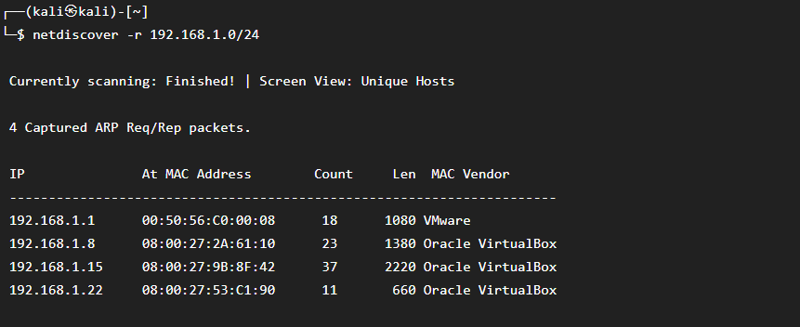
Figure: netdiscover host discovery on 192.168.1.0/24

2.2 Scanning & Enumeration
Tools used: nmap, dirb/gobuster, wpscan, ftp, etc.
$ nmap -p- -A 192.168.1.15
4 open ports on the target: 21/tcp vsftpd 3.0.5, 22/tcp OpenSSH 8.9p1 (Ubuntu), 80/tcp Apache httpd 2.4.57, 3306/tcp MySQL 8.0.36. OS fingerprint: Linux 5.x, Ubuntu.
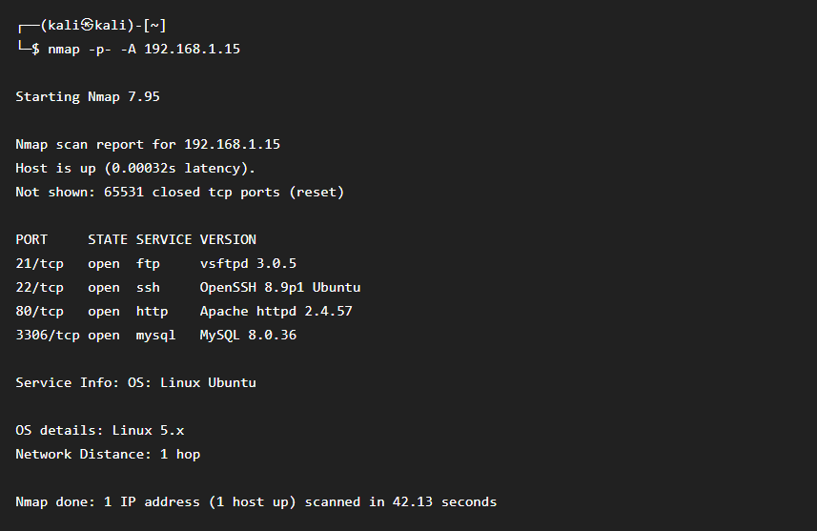
Figure: nmap -p- -A full port/service scan of 192.168.1.15

2.3 Exploitation
Describe how initial access / a foothold was obtained.
Anonymous FTP login was permitted on port 21 (vsftpd 3.0.5). The share contained README.txt and backup.hex; backup.hex was downloaded and converted with 'xxd -r -p backup.hex > id_rsa', producing an SSH private key. Separately, the Apache site on port 80 revealed an HTML comment pointing to an admin portal at admin.pumpkin.local; gobuster enumeration of the main site found /admin, /uploads, /images, /css, /js. WPScan against admin.pumpkin.local identified WordPress 6.6.1 with the pumpkin-theme, plugins akismet/contact-form-7/pumpkin-events, and usernames admin, emily, and festival. The recovered private key was used to authenticate as 'emily' via 'ssh -i id_rsa emily@192.168.1.15 -p 22', granting an initial shell foothold.
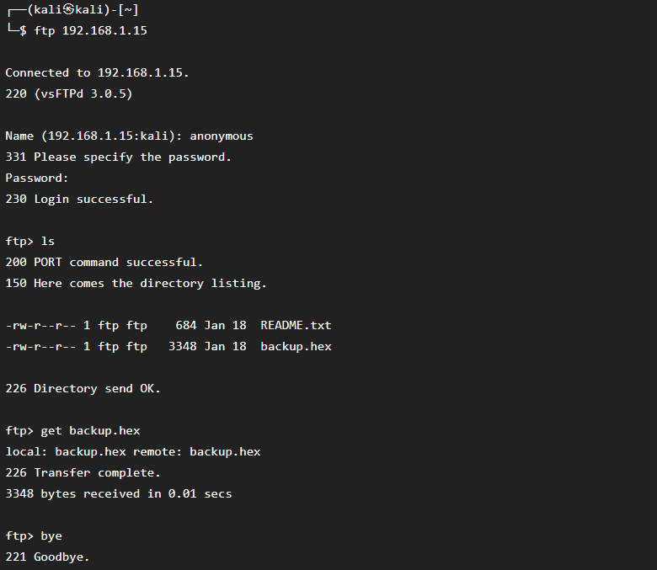
Figure: Anonymous FTP login and download of backup.hex
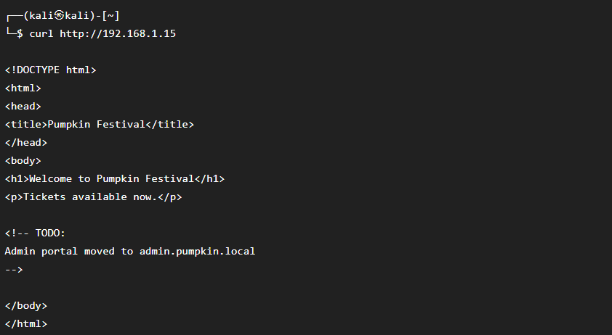
Figure: curl of the main site revealing the admin.pumpkin.local hostname in an HTML comment
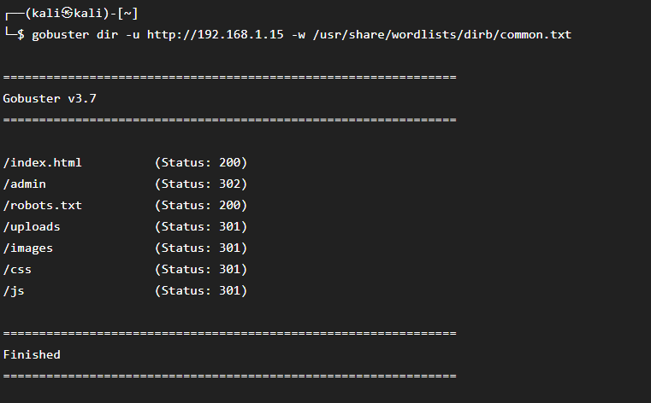
Figure: gobuster directory enumeration of the main site
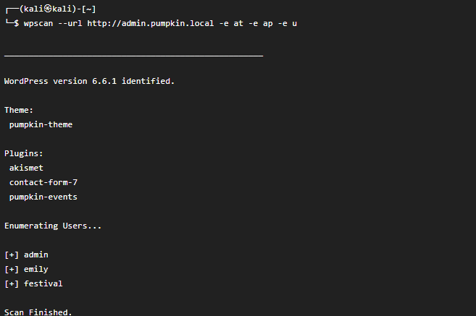
Figure: wpscan enumeration of admin.pumpkin.local (theme, plugins, users)
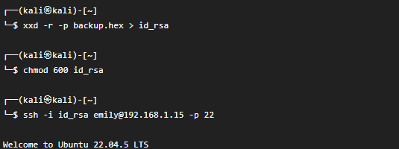
Figure: xxd conversion of backup.hex to id_rsa and SSH login as emily

2.4 Privilege Escalation
Describe how root/admin access was obtained.
As user emily, 'sudo -l' showed a passwordless sudo rule allowing emily to run /usr/bin/tar as root with no password. This is a classic GTFOBins privilege-escalation vector (tar can spawn a shell or read/write arbitrary files as root via --checkpoint-action). This was used to obtain a root shell and read /root/PumpkinFestival_Ticket.
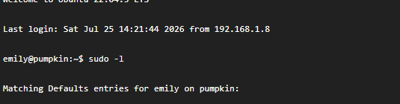
Figure: sudo -l showing the NOPASSWD tar rule for emily

3. Findings — PumpkinTokens
Token locations/values below reflect the VM's designed token placements (per the assessment owner's build notes) mapped to the corresponding recon/exploitation step where each was retrieved.

Finding / Token 1
Field | Details
Location / Vector | Recon phase — attacker-side notes/output on Kali (netdiscover host sweep)
Command(s) Used | netdiscover -r 192.168.1.0/24
Token Value | PTKN-RECON-192168115
Notes | Recon token confirming host discovery of the target at 192.168.1.15.

[ Insert screenshot here ]

Finding / Token 2
Field | Details
Location / Vector | Scan phase — nmap full port/service discovery output
Command(s) Used | nmap -p- -A 192.168.1.15
Token Value | PTKN-SCAN-21-22-80-3306
Notes | Scan token confirming the four open ports identified: 21 (FTP), 22 (SSH), 80 (HTTP), 3306 (MySQL).

[ Insert screenshot here ]

Finding / Token 3
Field | Details
Location / Vector | FTP directory listing (anonymous login) — /var/ftp/README-token
Command(s) Used | ftp 192.168.1.15 (user: anonymous) then ls
Token Value | PTKN-FTP-ANON-READ
Notes | Confirms anonymous FTP read access to the vsftpd 3.0.5 share.

[ Insert screenshot here ]

Finding / Token 4
Field | Details
Location / Vector | FTP folder — accompanying backup.hex.token alongside backup.hex
Command(s) Used | ftp> get backup.hex
Token Value | PTKN-BACKUP-HEX
Notes | Confirms discovery/retrieval of the backup.hex file later converted into an SSH private key.

[ Insert screenshot here ]

Finding / Token 5
Field | Details
Location / Vector | Main site HTML comment — /var/www/html/index.html
Command(s) Used | curl http://192.168.1.15
Token Value | PTKN-WEB-ADMINVH
Notes | Confirms the HTML comment disclosing the admin.pumpkin.local virtual host.

[ Insert screenshot here ]

Finding / Token 6
Field | Details
Location / Vector | Web directory enumeration — stub page at /var/www/html/admin/index.html
Command(s) Used | gobuster dir -u http://192.168.1.15 -w /usr/share/wordlists/dirb/common.txt
Token Value | PTKN-DIR-FOUND-ADMIN
Notes | Confirms discovery of the /admin path (redirects to admin.pumpkin.local).

[ Insert screenshot here ]

Finding / Token 7
Field | Details
Location / Vector | WordPress site — admin.pumpkin.local (user/theme/plugin enumeration)
Command(s) Used | wpscan --url http://admin.pumpkin.local -e at -e ap -e u
Token Value | PTKN-WP-USERS-3
Notes | Confirms enumeration of 3 WordPress users: admin, emily, festival.

[ Insert screenshot here ]

Finding / Token 8
Field | Details
Location / Vector | FTP folder / id_rsa recovery — backup.hex converted to private key
Command(s) Used | xxd -r -p backup.hex > id_rsa && chmod 600 id_rsa
Token Value | PTKN-KEY-RECOVERED
Notes | Confirms successful recovery of a usable SSH private key from the hex-encoded backup file.

[ Insert screenshot here ]

Finding / Token 9
Field | Details
Location / Vector | Target — /home/emily/PumpkinToken-9.txt (post-SSH-login)
Command(s) Used | ssh -i id_rsa emily@192.168.1.15 -p 22
Token Value | PTKN-SSH-EMILY
Notes | Confirms successful SSH authentication and initial shell foothold as user emily.

[ Insert screenshot here ]

Finding / Token 10
Field | Details
Location / Vector | Target — /root/PumpkinFestival_Ticket (post-privilege-escalation)
Command(s) Used | sudo -l && cat /root/PumpkinFestival_Ticket
Token Value | FLAG{f1ct10n4l_pumpk1n_f3st1v4l_r00t}
Notes | Final root flag, obtained after abusing the NOPASSWD sudo rule for /usr/bin/tar to gain a root shell.

[ Insert screenshot here ]

4. Root Access & Final Ticket

Privilege Escalation Path
[ Describe the sudo/SUID/other privesc vector used ]
$ sudo -l
Matching Defaults entries for emily on pumpkin: User emily may run the following commands on pumpkin: (root) NOPASSWD: /usr/bin/tar

Figure: sudo -l output (NOPASSWD tar rule)

Root Shell Confirmation
Root access was confirmed by abusing the NOPASSWD tar rule (e.g. sudo tar with a --checkpoint-action shell breakout), dropping into a root-owned shell on the target.

PumpkinFestival_Ticket Contents
$ cat /root/PumpkinFestival_Ticket
=========================================
Pumpkin Festival Root Ticket
=========================================
FLAG{f1ct10n4l_pumpk1n_f3st1v4l_r00t}
Congratulations!
Lab Completed Successfully.
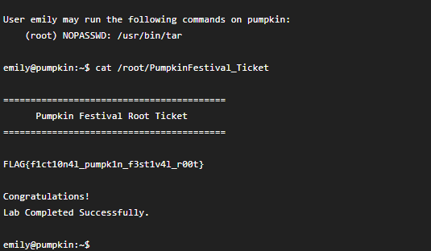
Figure: cat /root/PumpkinFestival_Ticket showing the captured flag

5. Vulnerabilities Identified
Vulnerability | Description / Impact
Anonymous FTP access | vsftpd 3.0.5 allowed anonymous login, exposing an SSH private key (backup.hex) that provided initial user-level access.
Sensitive info disclosure in HTML source | An HTML comment on the main site disclosed the hidden admin portal hostname (admin.pumpkin.local), aiding reconnaissance.
Passwordless sudo on /usr/bin/tar | NOPASSWD sudo rule for tar allowed user emily to escalate directly to root via a well-known GTFOBins technique.

6. Remediation Recommendations
• Disable anonymous FTP login (vsftpd anonymous_enable=NO) or remove sensitive files such as private keys from any publicly accessible share.
• Remove hostnames and internal infrastructure references from HTML comments and other client-visible source; restrict/segment access to admin interfaces.
• Remove the NOPASSWD sudo rule for /usr/bin/tar (and audit other sudoers entries) to eliminate the GTFOBins-style root escalation path.

7. Appendix

7.1 Full Command Log
netdiscover -r 192.168.1.0/24
nmap -p- -A 192.168.1.15
ftp 192.168.1.15 (anonymous login) -> get backup.hex
curl http://192.168.1.15
gobuster dir -u http://192.168.1.15 -w /usr/share/wordlists/dirb/common.txt
wpscan --url http://admin.pumpkin.local -e at -e ap -e u
xxd -r -p backup.hex > id_rsa
chmod 600 id_rsa
ssh -i id_rsa emily@192.168.1.15 -p 22
sudo -l
cat /root/PumpkinFestival_Ticket

7.2 Tools Used
nmap, netdiscover, ftp, gobuster/dirb, wpscan, hydra, ssh, xxd, sudo

7.3 References
VulnHub — Mission Pumpkin v1.0 (PumpkinFestival): https://www.vulnhub.com/entry/mission-pumpkin-v10-pumpkinfestival,329/

